Supporting Information

1. Electrospinning optimization
During electrospinning different parameters were tried to produce a defect-free scaffold.
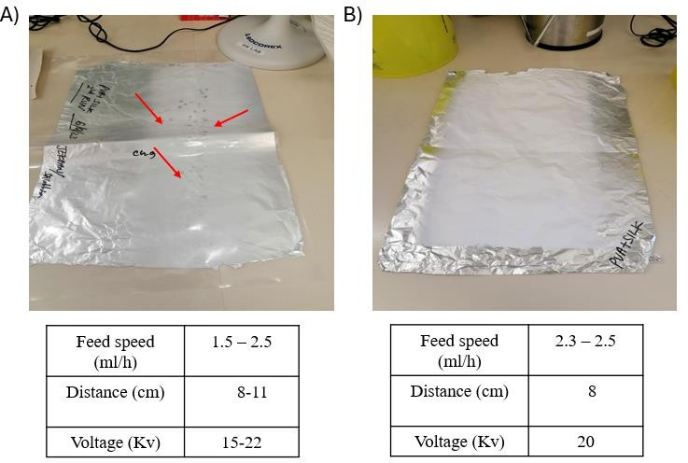

Supplementary Fig. 1. SEM analysis of the electrospun nanofibrous scaffolds. Photographic image of PVA-SF electrospun scaffolds (Trial 1- (A), Trial 2- (B)). As it can be clearly seen from the image (A), Several defects can be identified, highlighted in red arrow. No visible defects can be seen in image (B). The table represents the electrospun parameters used.

The scaffolds produced using previously established parameters showed lots of visible defects Trial 1, Fig. S1A. The second trial, after varying a few parameters, produced nanofibrous scaffolds without any major visible defects Fig. S1B.

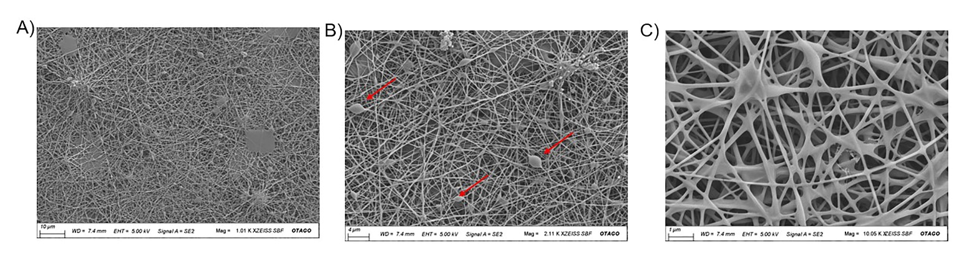

Supplementary Fig. 2. SEM analysis of the electrospun nanofibrous scaffolds. Representative SEM images of PVA-SF from Trial 2. (A) magnification 1000X (scale bar 10 µm), (B) magnification 2000X (scale bar 4 µm), (C) magnification 10,000X (scale bar 1 µm), more micro defects can be clearly seen, highlighted in red arrow. While there were no visible defects in the second trial Fig. S1B, SEM analysis (above) showed a high level of microdefects at different magnifications. This large defect will interfere with cell-matrix interactions, requiring more optimization.

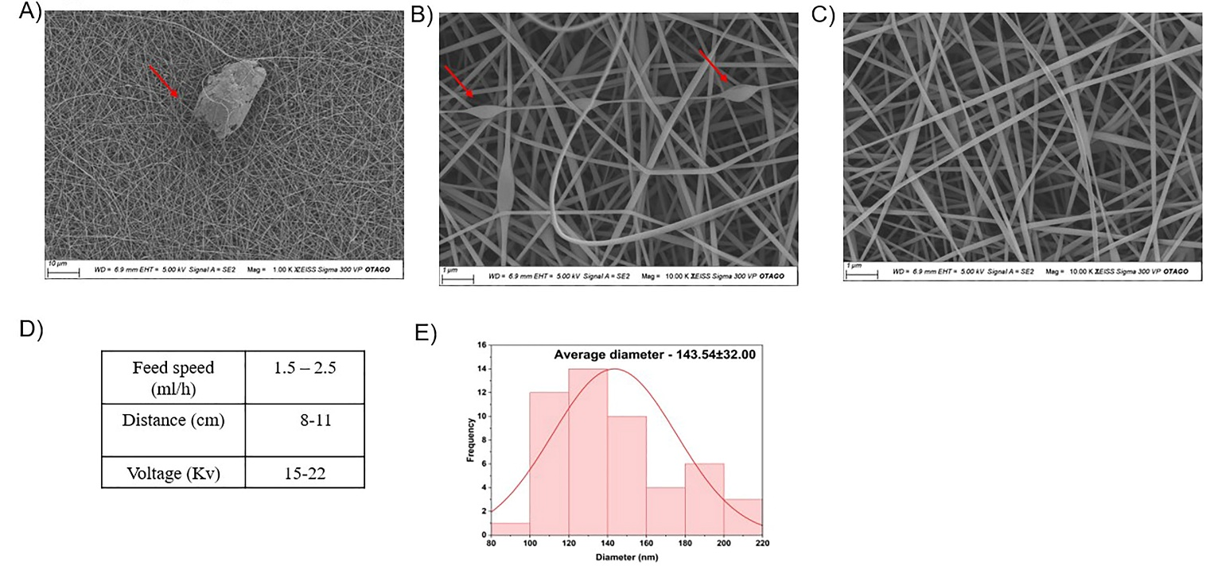

Supplementary Fig. 3. SEM analysis of the electrospun nanofibrous scaffolds. Representative SEM images of PVA-SF (Trial 3) (A) magnification 1000X (scale bar 10 µm), (B) magnification 5000X (scale bar 1 µm), (C) magnification 10,000X, (scale bar 1 µm). SEM following further optimizations showed the absence of big defects, apart from tiny nano defects (highlighted in red arrow, A&B). Majority of the scaffold showed uniform fibres (C), with fibre diameter of 143.54 nm±32.00 (standard deviation). These parameters meet the necessary size criteria for cell migration and growth. Their high surface area provides more sites for cell attachment and promotes tissue regeneration. Their
nanoscale structure closely mimics the native extracellular matrix, enhancing cell adhesion and differentiation. These scaffolds can be precisely tailored to have specific properties, balancing structural integrity with porosity for optimal cell growth. Additionally, they exhibit improved mechanical properties, essential for withstanding physiological forces. Further optimization resulted in defect-free PVA-SF scaffolds as confirmed by SEM Fig. 2. Fig. S5 (PVA- SF Scaffold) and Fig. S6 (Bioscaffold) shows three independent repeats of defect-free matrix developed using the optimized parameters.

2. Viscosity analysis of the electrospinning solution

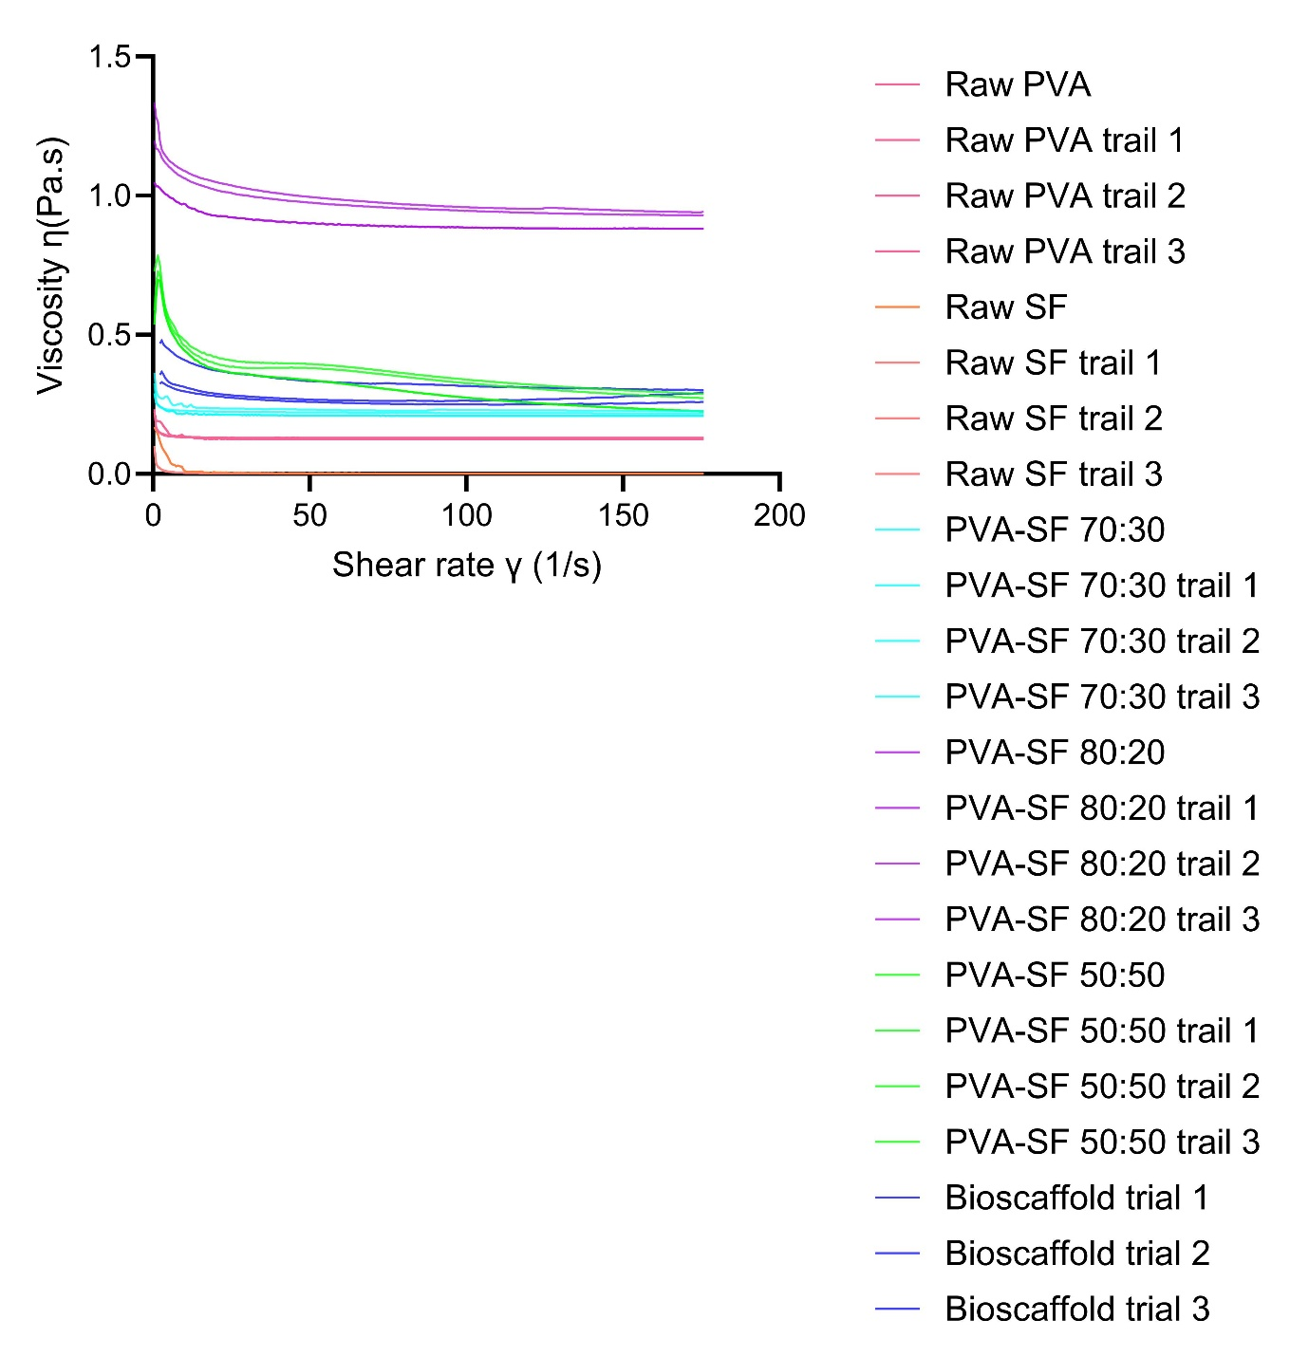

Supplementary Fig. 4. Rheology analysis of the spinning solution. The viscosity graph of Raw PVA, Raw SF and PVA-SF at ratios of 70:30, 80:20, PVA-SF 50:50, and after incorporating the natural components (bioscaffold). The PVA-SF 50:50 ratio and bioscaffold solution exhibited a non-Newtonian fluid behaviour, while other preparations exhibit Newtonian fluid behaviour. In the viscosity graphs, the X-axis represents the shear rate, and the Y- axis represents the viscosity.

3. SEM Analysis

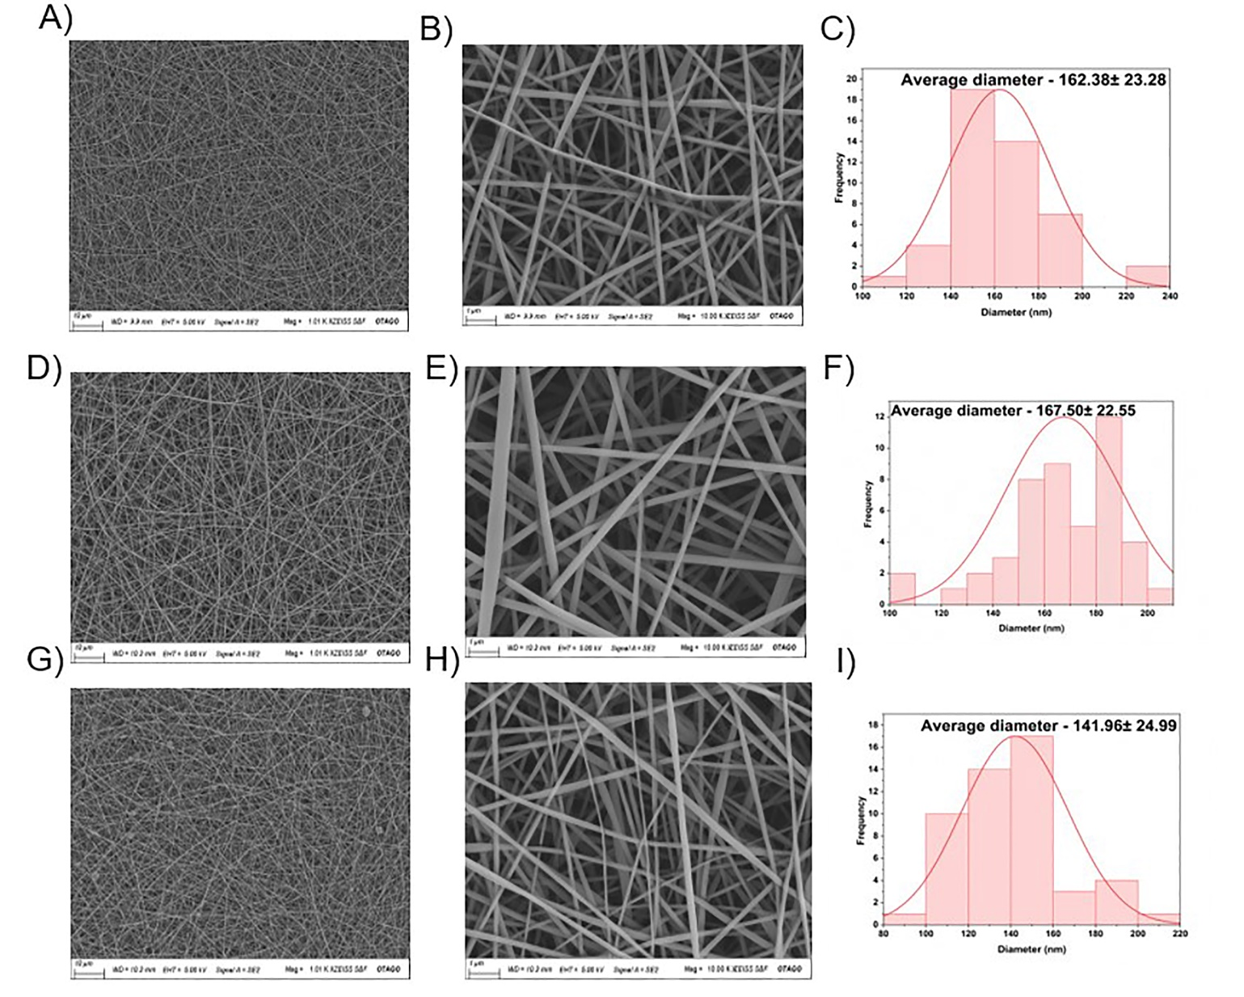

Supplementary Fig. 5. SEM analysis of the electropsun nanofibrous scaffolds. Representative SEM images of PVA-SF scaffolds (repeat 1, 2, 3) (A, D, G) magnification 1000X (scale bar 10 µm) (B, E, H) magnification 10,000X (scale bar 1 µm), no major and minor defects can be seen. Quantitative bar graph showing the nanofibre diameter of PVA-SF fibres (C, F, I). The diameter was in the range r1 (C)-162.38 ±23.28 nm, r2 (F)-167.50 ±22.55 nm, r3(I)-141.96 ±24.99 nm.

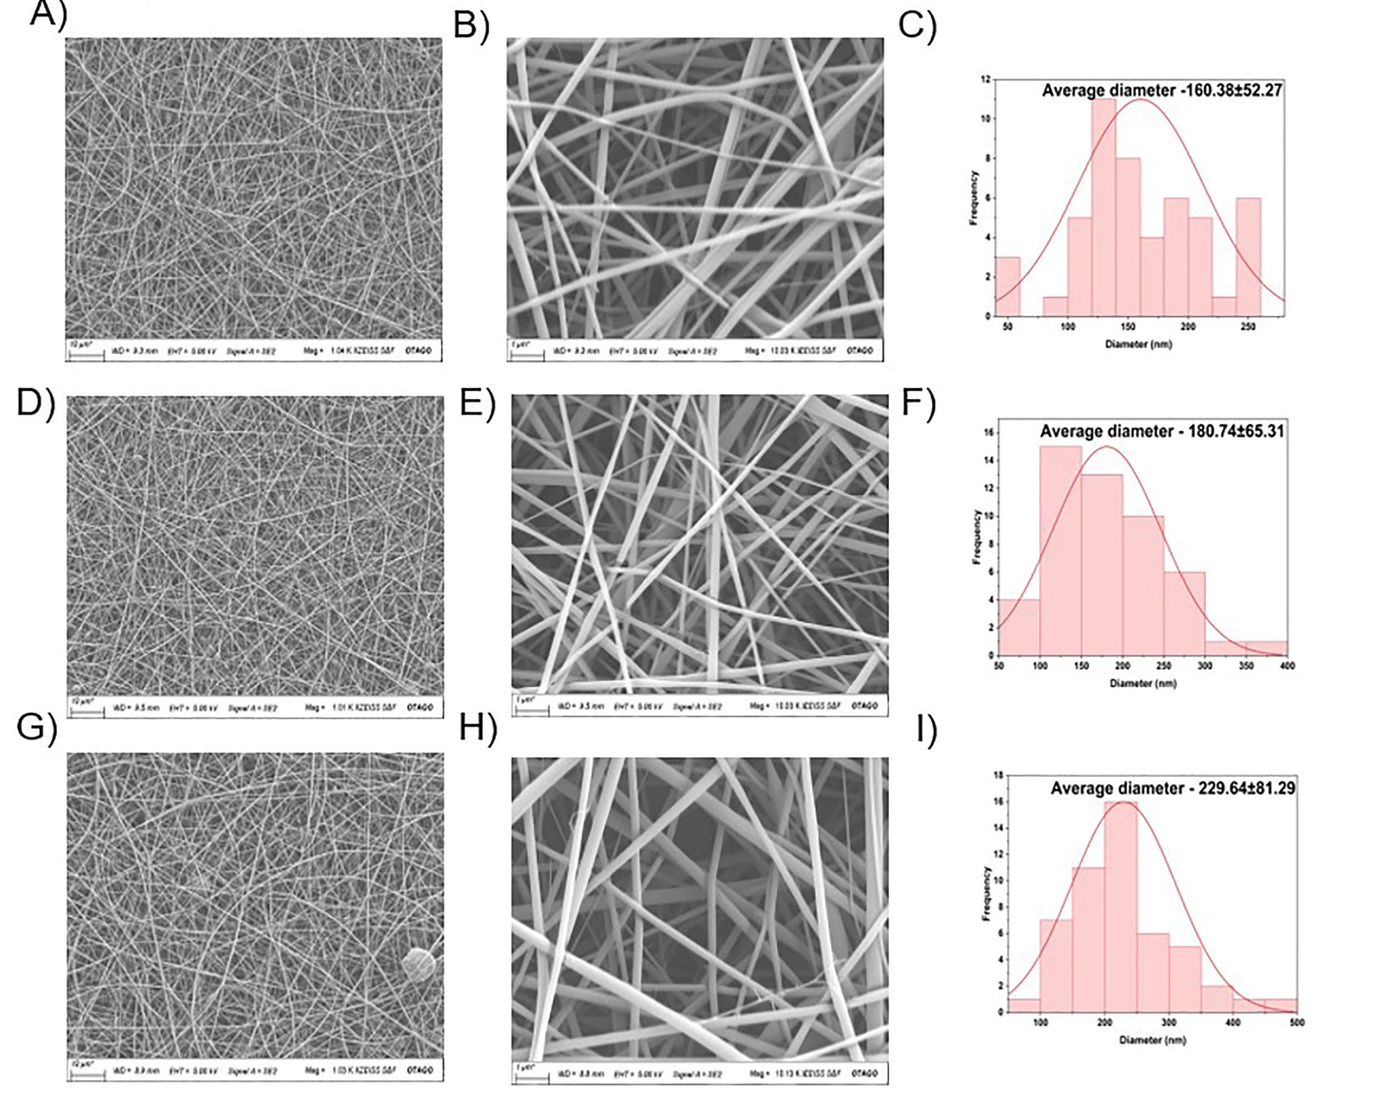

Supplementary Fig. 6. SEM analysis of the electrospun nanofibrous scaffolds. Representative SEM images of bioscaffolds (repeat 1,2,3) (A, D, G) magnification 1000X (scale bar 10 µm) (B, E, H) magnification 10,000X (scale bar 1 µm), no major and minor defects can been seen. Quantitative bar graph showing the nanofibre diameter of bioscaffold fibres (C, F, I). The diameter was in the range r1 (C)-160.38 ±52.27 nm, r2 (F)-180.74 ±65.31 nm, r3 (I)-229.64 ±81.29 nm.

3. FTIR analysis

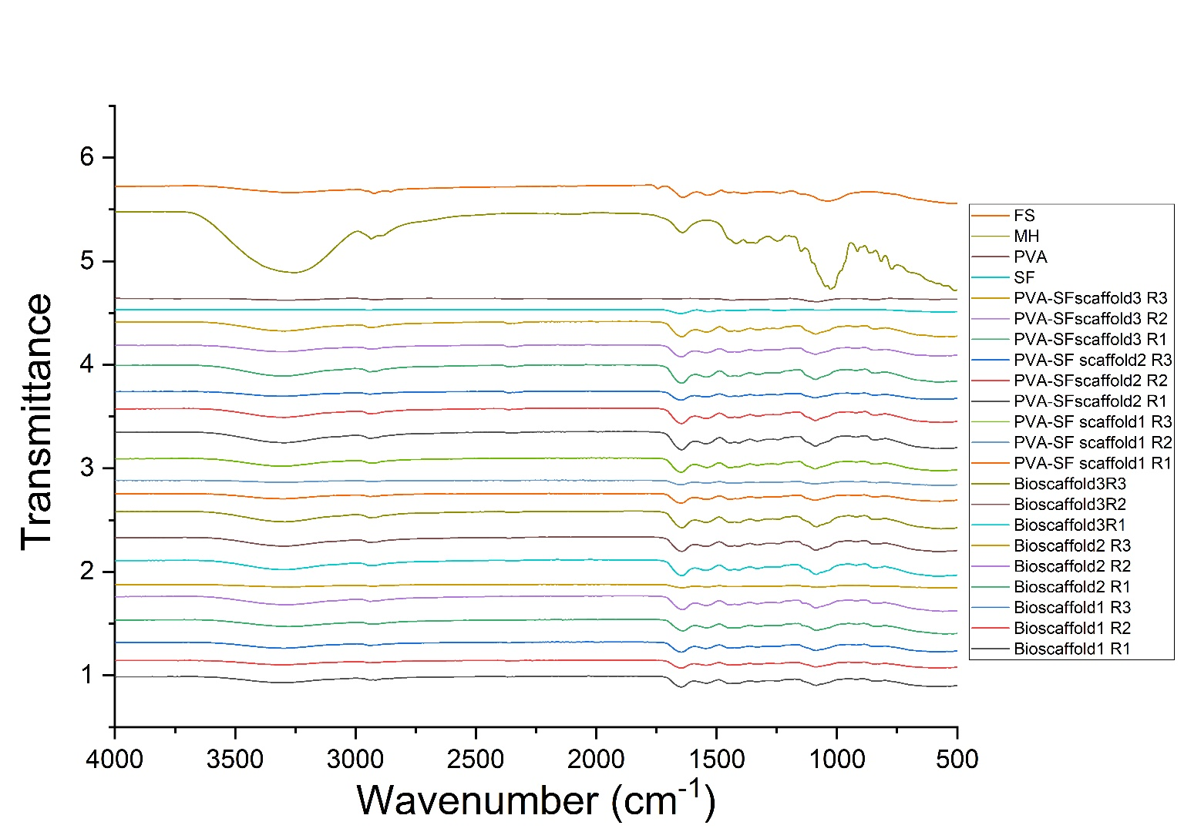

Supplementary Fig. 7. ATR-FTIR spectroscopy analysis of the electrospun nanofibrous scaffolds. Representative ATR-FTIR spectra of Raw Fenugreek seeds, Raw Manuka honey, Raw PVA, Raw SF, and an overlaid comparison with the PVA- SF composite and bioscaffold. In the PVA-SF spectrum, notable shifts occur at peaks 3282, 1654, and 1544 cm⁻¹, which correspond to the O−H group, amide I, and amide II, respectively. In the bioscaffold, shift changes occur at amide I, amide II, and 1030 cm⁻¹, which corresponds to C−O stretching. The spectra span a range from 400 to 4000 cm⁻¹, with the x-axis representing wavenumber (cm⁻¹) and the y-axis indicating percentage transmittance.

4. TGA analysis

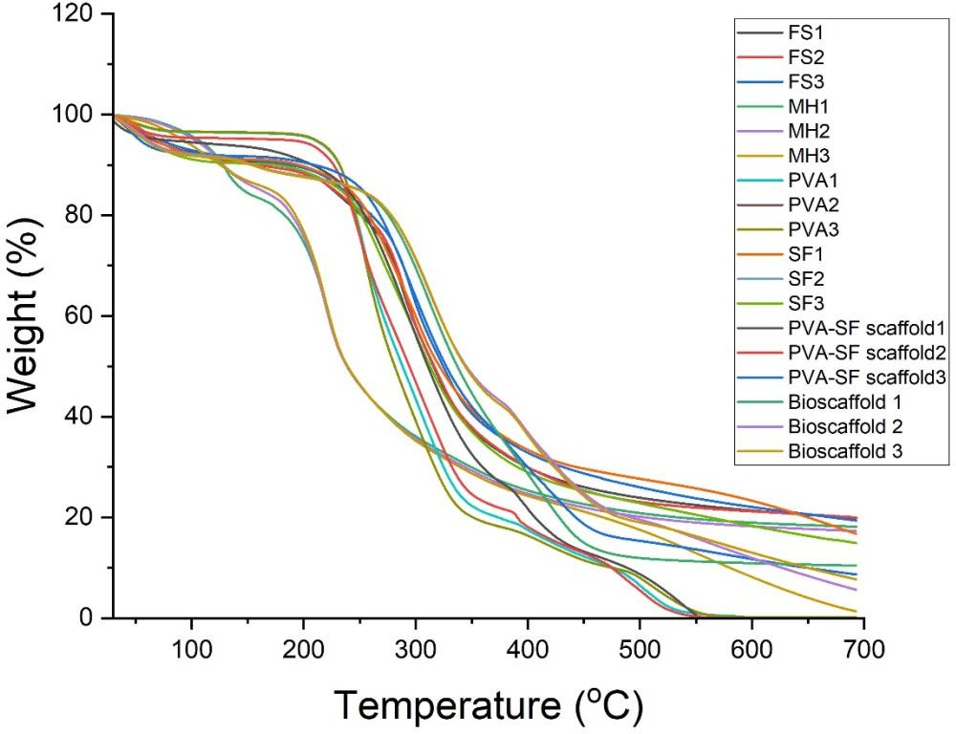

Supplementary Fig. 8. Thermal analysis of the electrospun nanofibrous scaffolds. Representative TGA thermogram of Raw Fenugreek seed, Manuka honey, PVA, SF and PVA-SF scaffold, bioscaffolds composites. X axis represents the temperature (°C), and the Y axis represents the percentage of weight loss.

5. DSC analysis

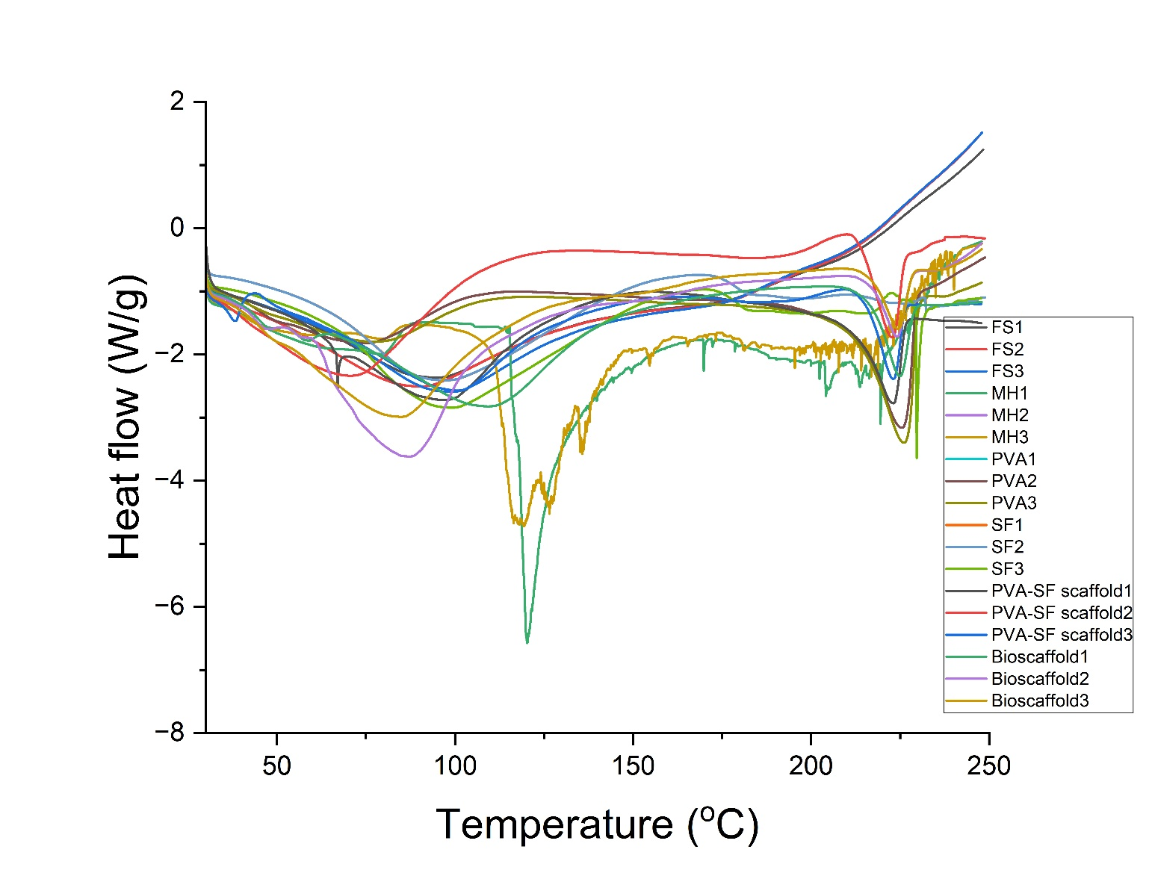

Supplementary Fig. 9. DSC thermogram analysis of the electrospun nanofibrous scaffolds.
Representative trace of DSC thermogram of Raw Fenugreek Seed, Manuka honey, PVA, SF, PVA-SF, and bio composites PVA-SF scaffold and bioscaffold. Y axis represents the heat flow, and the X axis represents the temperature (°C).

6. Scratch assay

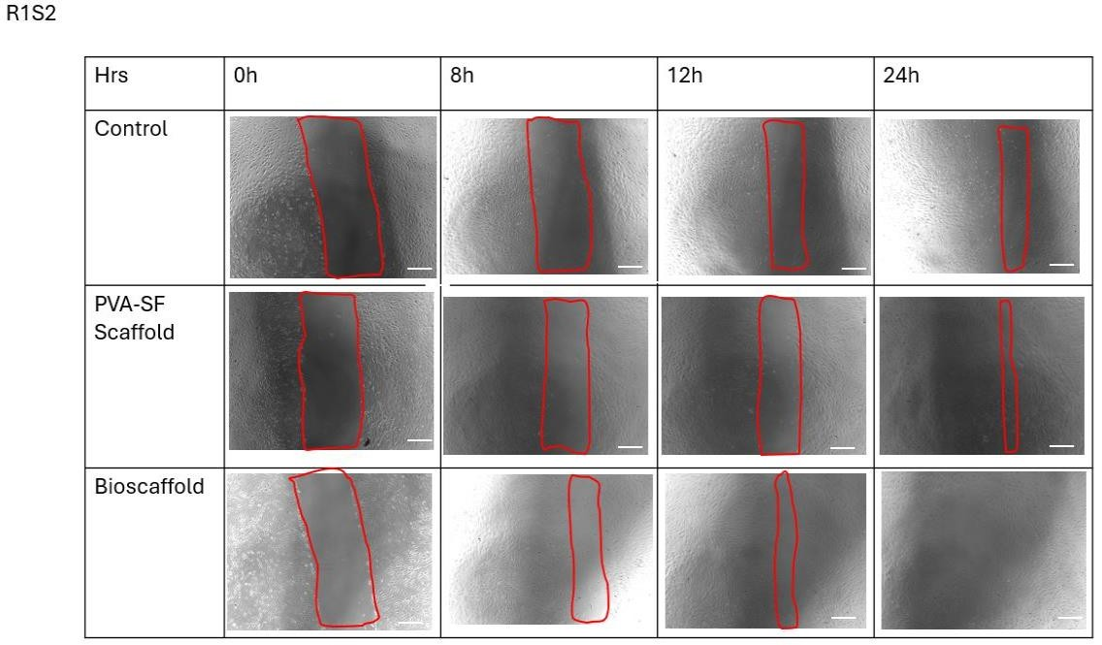
Supplementary Fig. 10.1. Wound healing analysis of the electrospun nanofibrous scaffold. Representative brightfield microscopic images showing the migration of HUVECs at different time points. Images were captured at 4X magnification. Red box indicates the wound area. Scale bar is 750 µm.

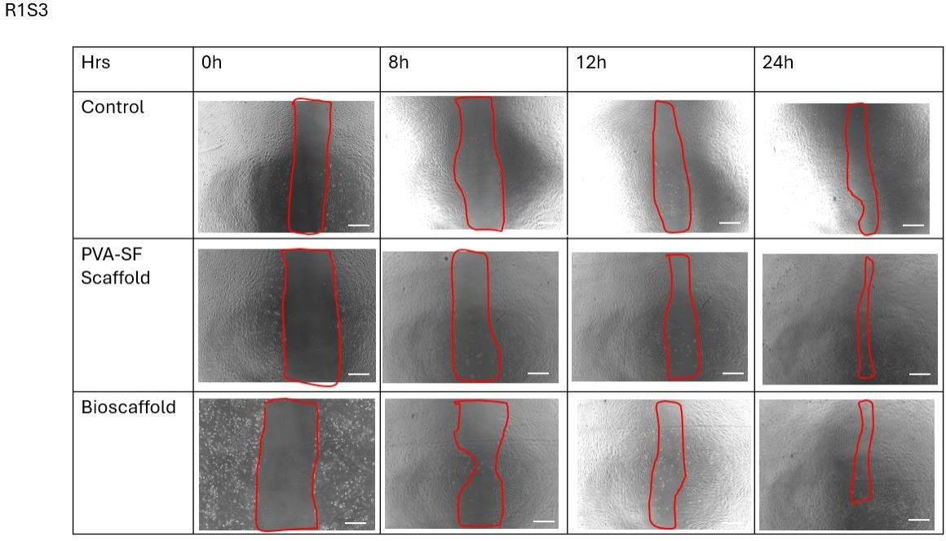
Supplementary Fig. 10.2. Wound healing analysis of the electrospun nanofibrous scaffolds. Representative brightfield microscopic images showing the migration of HUVECs at different time points. Images were captured at 4X magnification. Red box indicates the wound area. Scale bar is 750 µm.
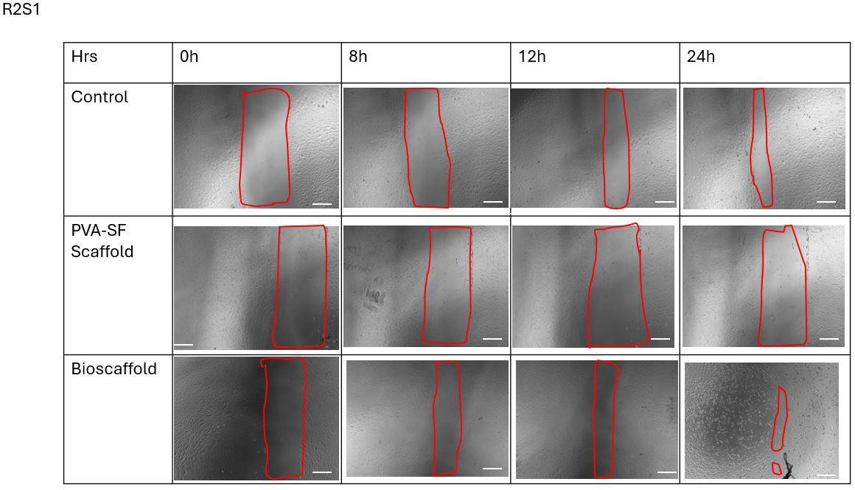

Supplementary Fig. 10.3. Wound healing analysis of the electrospun nanofibrous scaffolds. Representative brightfield microscopic images showing the migration of HUVECs at different time points. Images were captured at 4X magnification. Red box indicates the wound area. Scale bar is 750 µm.

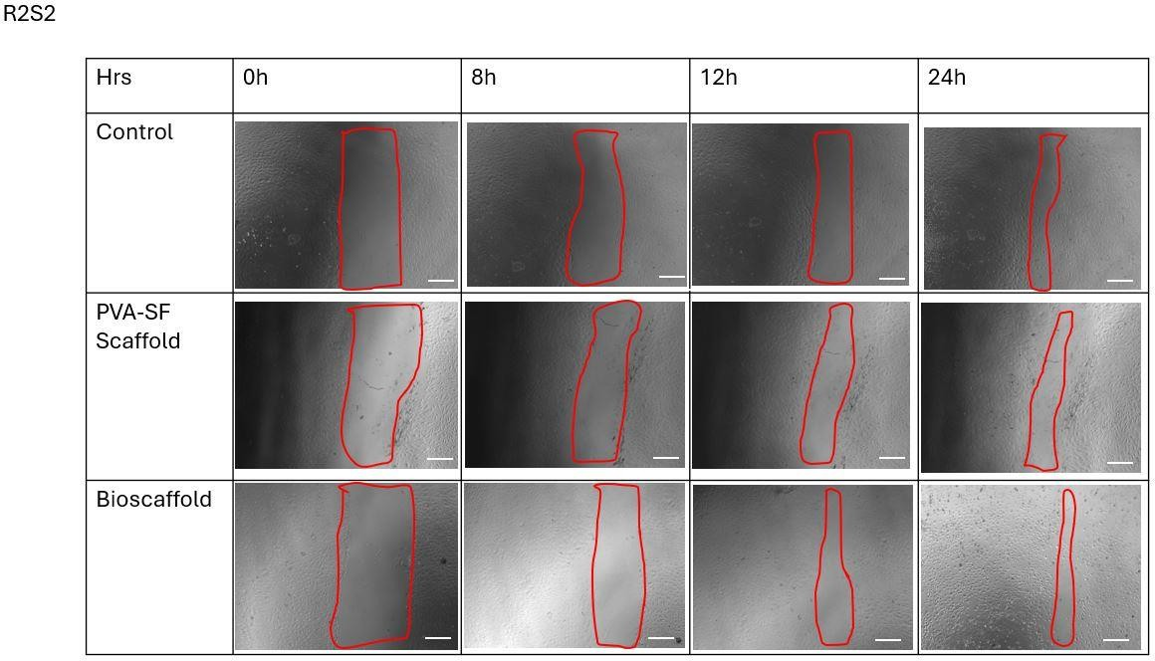

Supplementary Fig. 10.4. Wound healing analysis of the electrospun nanofibrous scaffolds. Representative brightfield microscopic images showing the migration of HUVECs at different time points. Images were captured at 4X magnification. Red box indicates the wound area. Scale bar is 750 µm.

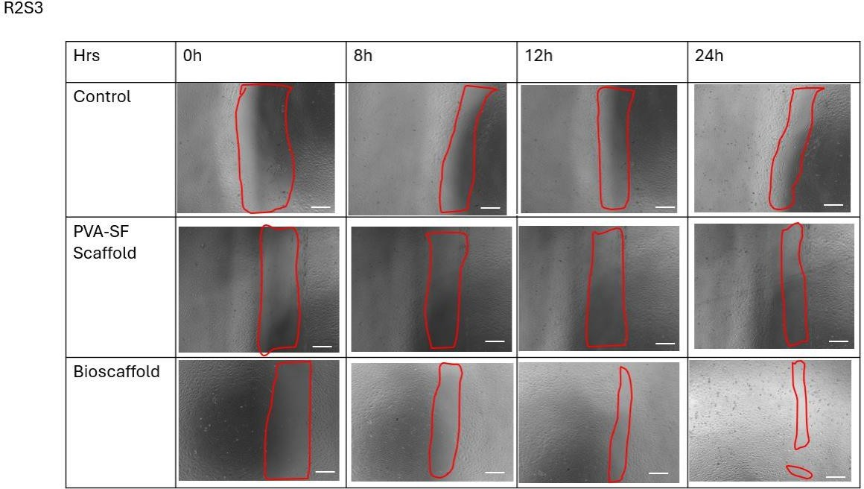

Supplementary Fig. 10.5. Wound healing analysis of the electrospun nanofibrous scaffolds. Representative brightfield microscopic images showing the migration of HUVECs at different time points. Images were captured at 4X magnification. Red box indicates the wound area. Scale bar is 750 µm.

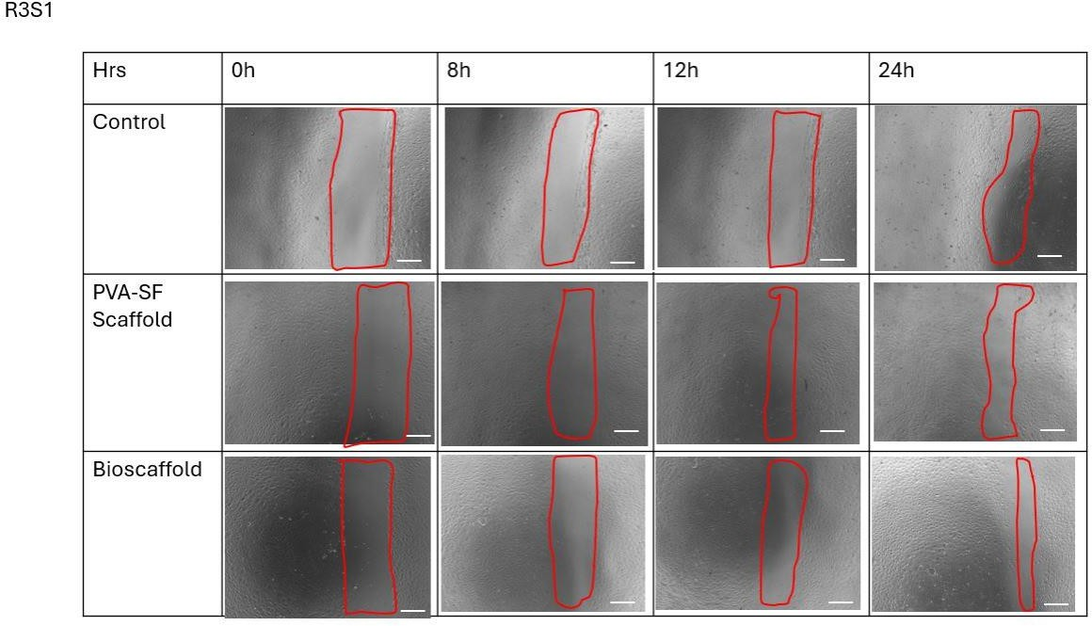

Supplementary Fig. 10.6. Wound healing analysis of the electrospun nanofibrous scaffolds. Representative brightfield microscopic images showing the migration of HUVECs at different time points. Images were captured at 4X magnification. Red box indicates the wound area. Scale bar is 750 µm.

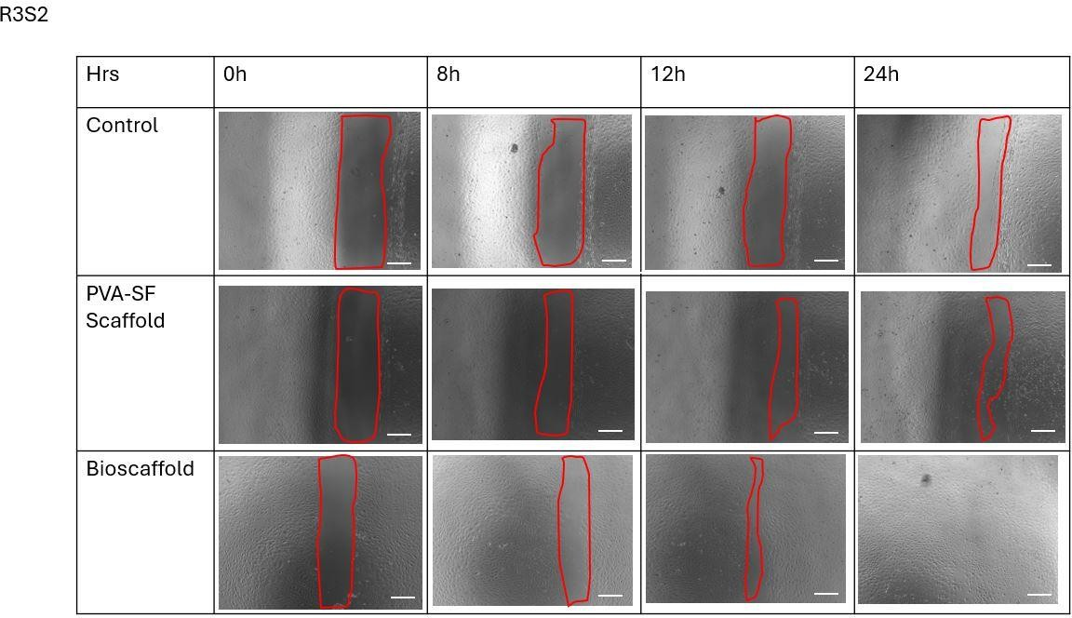

Supplementary Fig. 10.7. Wound healing analysis of the electrospun nanofibrous scaffolds. Representative brightfield microscopic images showing the migration of HUVECs at different time points. Images were captured at 4X magnification. Red box indicates the wound area. Scale bar is 750 µm.

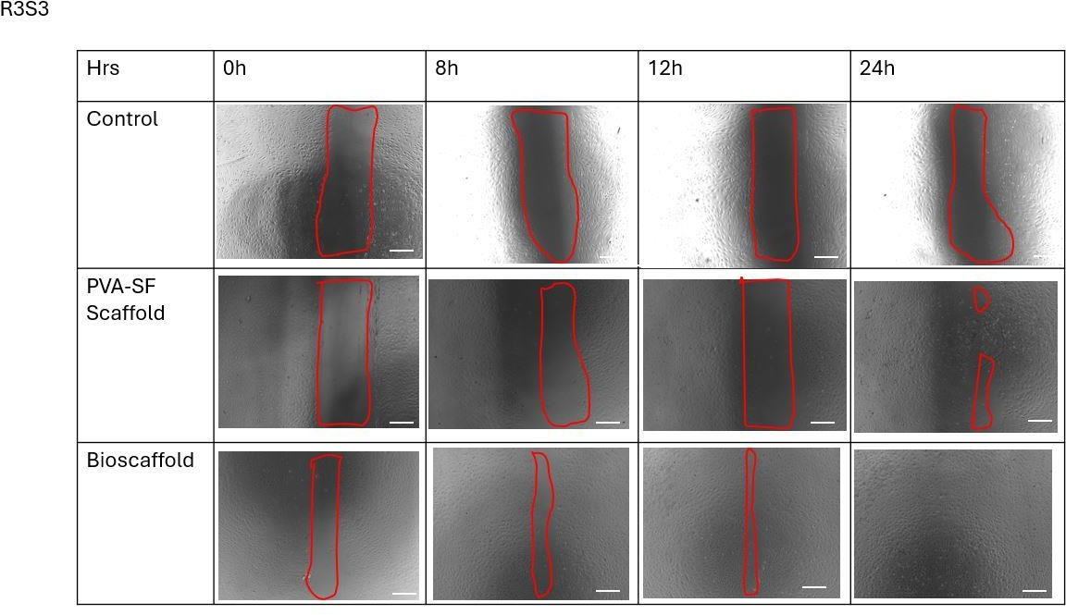

Supplementary Fig. 10.8. Wound healing analysis of the electrospun nanofibrous scaffolds. Representative brightfield microscopic images showing the migration of HUVECs at different time points. Images were captured at 4X magnification. Red box indicates the wound area. Scale bar is 750 µm.

